UNDERSTANDING THE BRAIN
Ever wonder what your brain really does?
How does the brain help you learn?
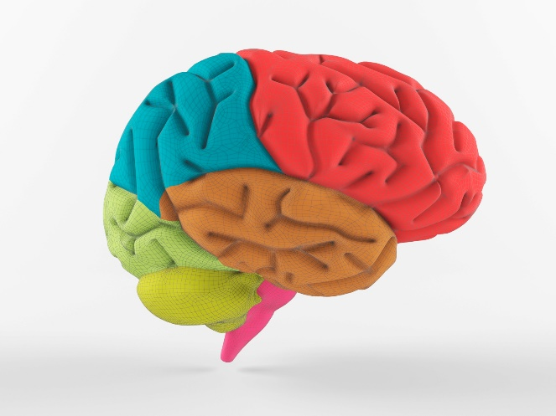
What parts of the brain make you who you are?

WHEN AND WHERE
Friday December 13, 2019
9:00 am – 12:00 pm
Ft. Lupton High School

WHAT YOU WILL LEARN
Using models and clay we will build the human brain from the inside out. We will learn the anatomy and functions of different parts of the brain.

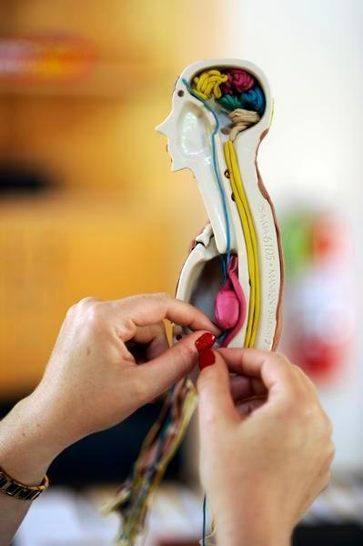

THE MIND CANNOT FORGET WHAT THE HANDS HAVE LEARNED. ™
If you are interested please email:
Nikki Chima at
achima@weld8.org
https://formstack.io/277A2
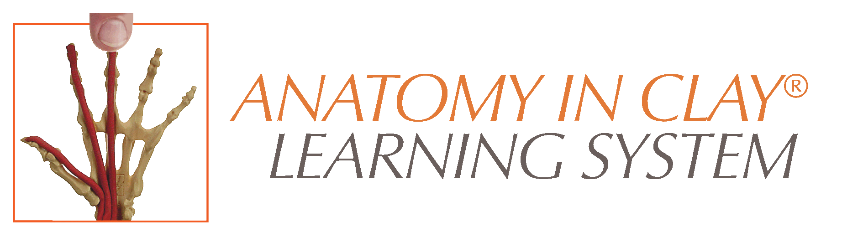
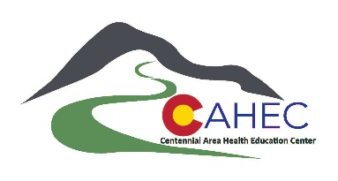
From Zahourek Systems, Inc
Erika Greenberg MSN,RN
egreenberg@cahec.org

