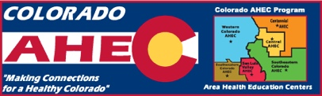

Colorado AHEC

2015-2016 Annual Report Highlights

*Enhancing access to quality healthcare, particularly primary and preventive care, by improving the supply and distribution of healthcare professionals through community/academic educational partnerships.*

95,953

participants*

*Pipeline programs* expose students to health careers and develop intent to pursue post-secondary education in primary healthcare professions.

facilitated

927

unique student rotations

*Clinical training* improves readiness, willingness, and ability of health professions trainees to serve in primary care, and rural and underserved community settings.

85,614

grades 9-16 participants

(many thousands more participated at the K-8 level)

774

total health professions students placed in

rural and underserved locations

*(includes students in multiple rotations)*

*employed in medically underserved communities*

Headquarters Office: 13120 E. 19th Ave, MS-F433, Aurora, CO 80045

phone: 303-724-0348. fax: 303-724-0891

[www.ucdenver.edu/coahec](http://www.ucdenver.edu/coahec)

*Numbers do not include thousands of K-8 and community outreach participants and do include duplicate counts where individuals have participated in multiple programs.

485

continuing education participants

*Continuing education programs* address key issues in health professional shortage areas by providing health professionals with access to resources that support practice, reduce professional isolation, disseminate best practices, and improve quality of healthcare for medically underserved communities and health disparities populations.

*underrepresented minorities*

*from rural backgrounds*

*from disadvantaged backgrounds*

9,186

curriculum-based pipeline program participants

* 201 medical students
* 573 associated health professions students

25%

*Training sites* used include:

* 137 primary care setting
* 138 located in a medically

underserved community

* 161 located in a rural area

33%

23%

43%