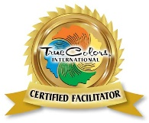

For more information contact:

**Monica Mika**

Certified True Colors Facilitator

[www.cahec.org](http://www.cahec.org)

(970) 330-3608

2105 Clubhouse Drive

Greeley, CO 80634

The True Colors system is built upon a teaching model of personality identification that recognizes and celebrates people’s true character and translates complex temperament theory into practical information and actionable programs.

We use colors

– Orange, Gold, Green, and Blue –

to differentiate the four central primary personality types.

Key Results

* We address ineffective communication at the individual, team, and organizational level.
* We help organizations maximize their most important resource: people.
* We provide the tools and strategies, then show you how to implement them.
* We help establish a culture that values difference and creates unity.

**TRUE COLORS® For Healthcare**

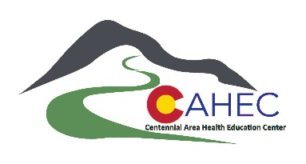

**The True Colors Process**

Self-discovery is the beginning of the True Colors process. Customized to the needs and goals of your organization, our first step is to help you take every team member through a True Colors workshop of

self-discovery.

Together, we can improve every interaction between every employee in your organization. We empower your teams to meet challenges creatively and collaboratively. Outcomes are: improved communication, reduced conflict, greater collaboration, and improved teamwork.



**Why Use True Colors in Healthcare?**

We equip attendees with tools to communicate

in a way that is best suited to the personality of each patient. When healthcare workers understand how clients prefer to be engaged, they quickly find that communication and productivity increases, allowing for better health outcomes.

**For Employees**

* Communication Skills
* Self-Esteem
* Employee Engagement
* Collaborative Teamwork
* Employee Productivity
* Performance
* Customer Service & Interaction

**For Management**

* A Positive Workplace
* Respect & Trust Building
* Employee Retention
* Stronger Leadership
* Increased Diversity and Inclusion
* Improved Conflict Resolution Skills
* Acquisition of Key Talent